MATLAB SIMULATION OF PASSBAND TRANSMISSION WITH BER ANALYSIS UNDER MULTIPATH FADING CHANNELS
Analog and Digital Communication — Experiment 24
Date of Experiment | 12/10/2026
Performed By | Lokesh A
Register Number | 192512293
1. Aim
To simulate a BPSK transmission system over a multipath fading channel with additive white Gaussian noise (AWGN), detect the received bits, calculate the bit error rate (BER), and compare the transmitted and detected data using MATLAB plots.
2. MATLAB Program
clc;
clear;
close all;
% Parameters
N = 1000;
bits = randi([0 1],N,1);
% BPSK Modulation
tx = 2*bits - 1;
% Multipath Fading Channel
h = [1 0.5 0.3];
fade = filter(h,1,tx);
% Add AWGN
rx = awgn(fade,10,'measured');
% Detection
bits_rx = rx > 0;
% BER Calculation
[~, BER] = biterr(bits,bits_rx);
fprintf('BER = %f\n',BER);
% Plots
figure;
subplot(3,1,1)
plot(tx)
title('Transmitted BPSK Signal')
grid on
subplot(3,1,2)
plot(rx)
title('Received Signal (Multipath + AWGN)')
grid on
subplot(3,1,3)
stem(bits(1:50),'b')
hold on
stem(bits_rx(1:50),'r')
title(['BER = ' num2str(BER)])
legend('Original','Detected')
grid on
3. Output
The first plot shows the transmitted BPSK signal, with input bits mapped to −1 and +1. The second plot shows the received signal after the multipath channel and AWGN, where channel effects and noise alter the waveform. The third plot compares the original and detected bits for the first 50 bits and displays the calculated BER.
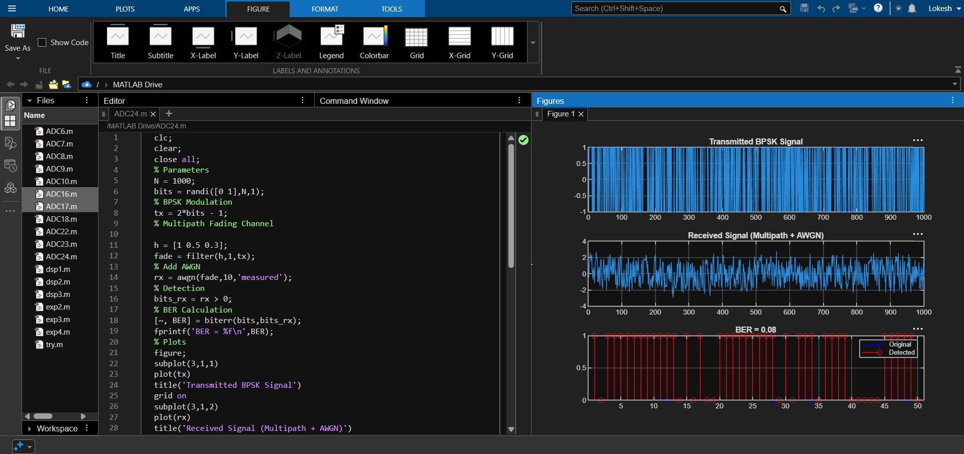
Figure 1: MATLAB editor, received signal, and BER comparison output.
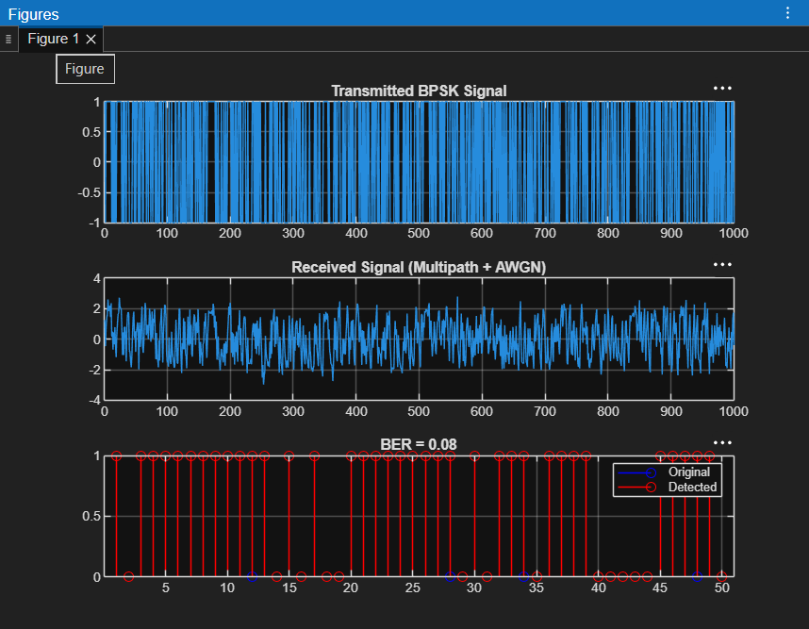
Figure 2: MATLAB plots for transmitted BPSK, received multipath-plus-AWGN signal, and detected bits.
4. Simulation Parameters
Parameter | Value
Number of bits (N) | 1000
Modulation scheme | Binary Phase Shift Keying (BPSK)
Multipath channel impulse response | h = [1 0.5 0.3]
Channel model | Multipath filtering followed by AWGN
Signal-to-noise ratio | 10 dB
Detection rule | rx > 0
Performance metric | Bit Error Rate (BER)
5. Applications
- Evaluating digital communication links affected by multipath propagation.
- Studying bit detection performance in noisy wireless channels.
- Comparing transmitted and detected binary data.
- Demonstrating BER as a quantitative measure of communication reliability.
6. Procedure
- Generate 1000 random binary bits.
- Map each bit to a BPSK symbol using tx = 2*bits − 1.
- Pass the transmitted symbols through the specified multipath filter.
- Add AWGN at 10 dB SNR.
- Detect the bits using a zero-threshold decision rule.
- Calculate and display the BER, then plot the transmitted signal, received signal, and first 50 original/detected bits.
7. Result and Discussion
The MATLAB simulation produces the transmitted BPSK waveform, the received waveform after multipath filtering and AWGN, and a comparison of original and detected bits. The BER quantifies the bit-decision errors for the generated data. The numerical BER depends on the randomly generated bit sequence and the noise realization, so it may vary between runs.
8. Conclusion
A BPSK communication link was simulated under multipath channel effects and AWGN using MATLAB. The received samples were detected with a zero-threshold decision rule, and the BER was calculated to evaluate transmission performance. The plots provide a visual comparison of the transmitted signal, the noisy received signal, and the detected bits.
DONE BY
Lokesh A
Register Number: 192512293
B.E. Electronics and Communication Engineering (ECE)

